Assignment

on

**Informatica**

for Hexaware – Batch 02

BY

Mouli S

Moulisankar2002@outlook.com



# Contents

1. Assignments on Informatica 4
   1. Questions Set - 01 4
   2. Questions Set - 02 5
   3. Questions Set - 03

# Questions Set - 01

* + 1. Create Job with source as excel and target as flat file delimited with;

Mappings:

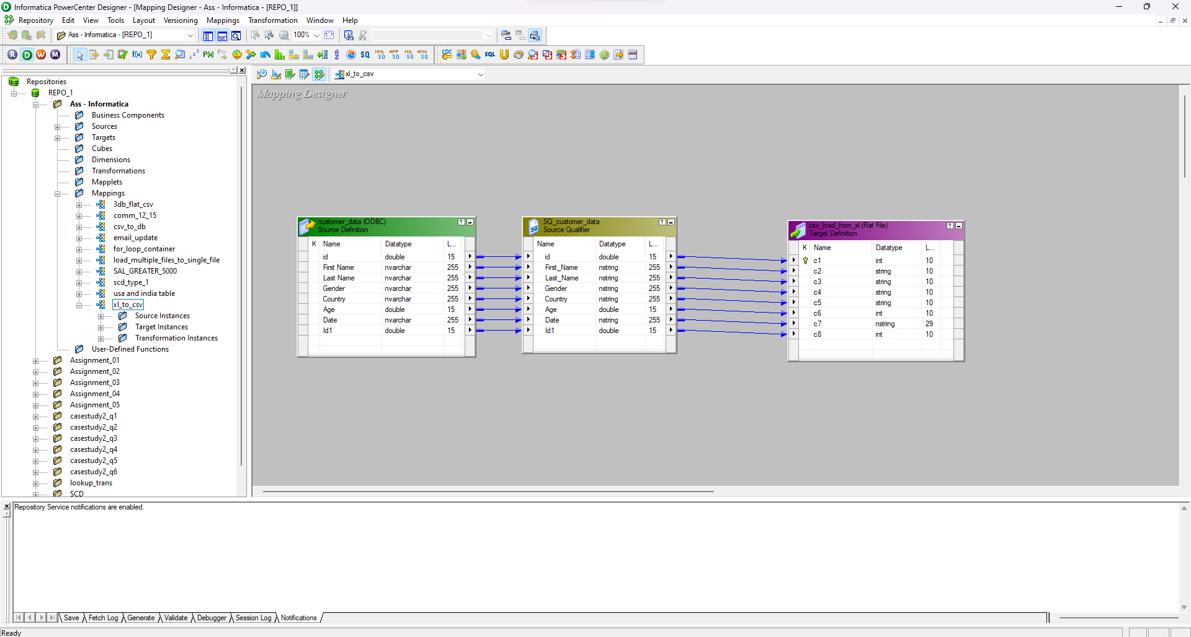

* + 1. Create Job having source as flat file, database table having same column name, type and numbers of column and write to database.

Mappings:

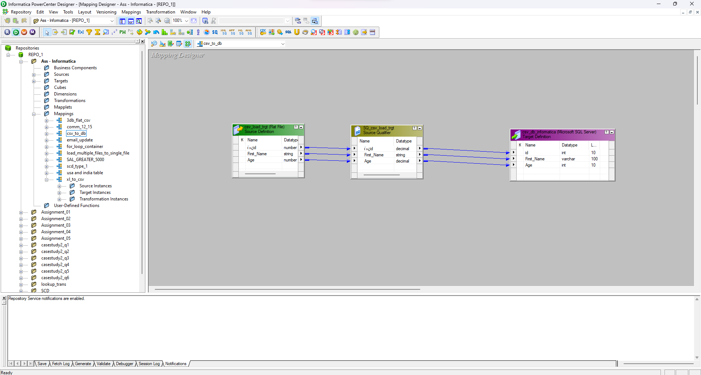

Database:

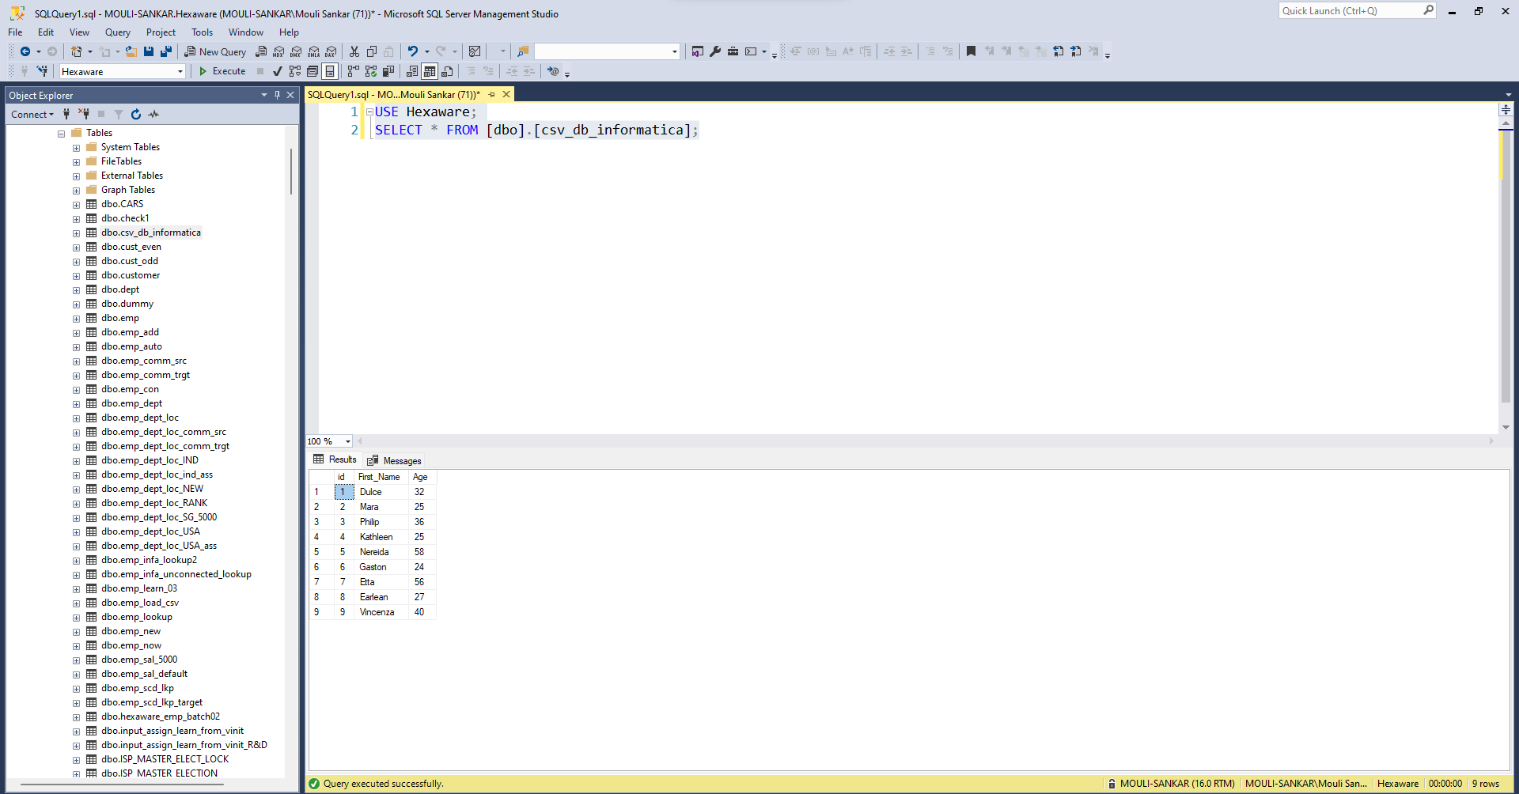

* + 1. Create Variable at mapping level – “learn_from_vinit” and generate email id like first_name + ‘@’ + ‘learnfromvinit’ + ‘.com’

Mappings:

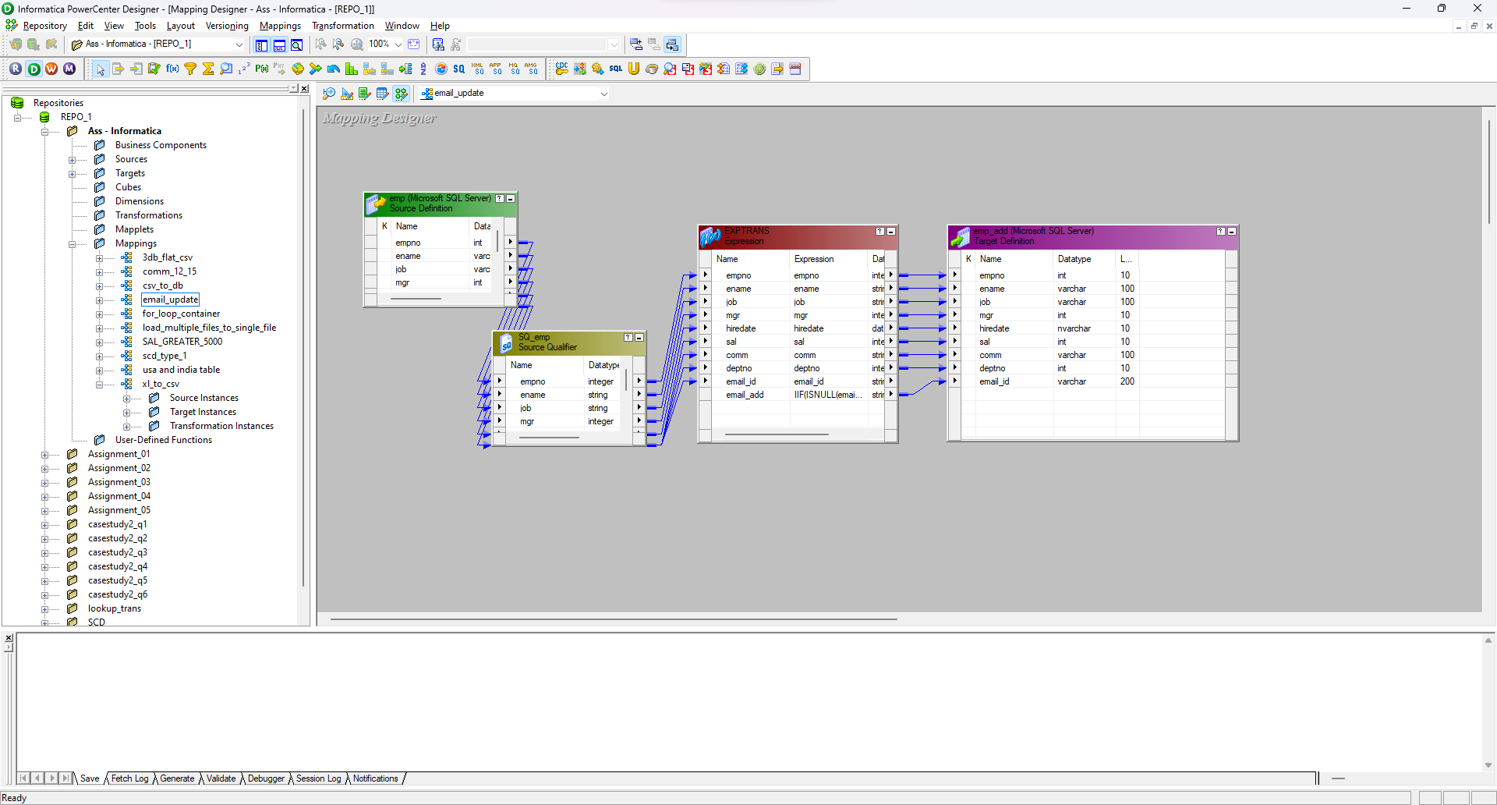

Database:

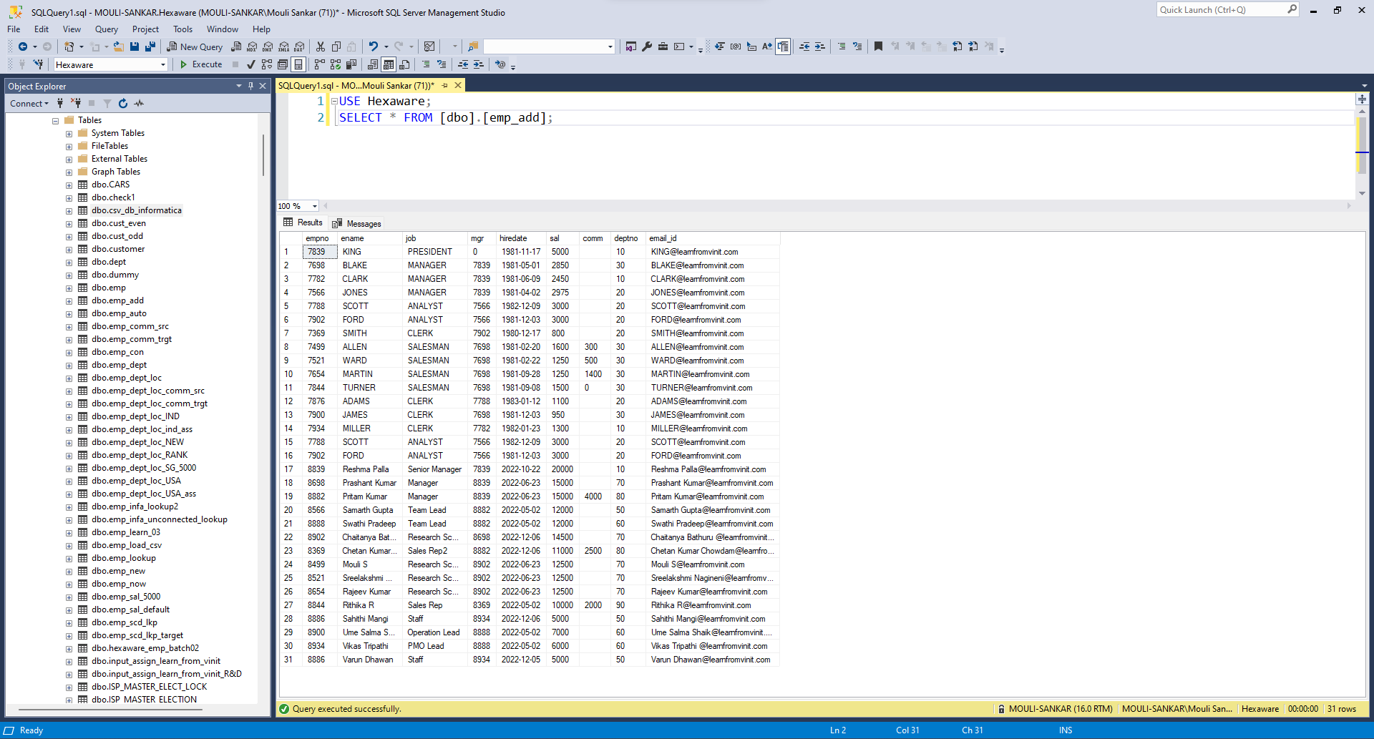

* + 1. Move data in 2 tables on basis of salary from emp table – greater than 5000 and default.

Mappings:

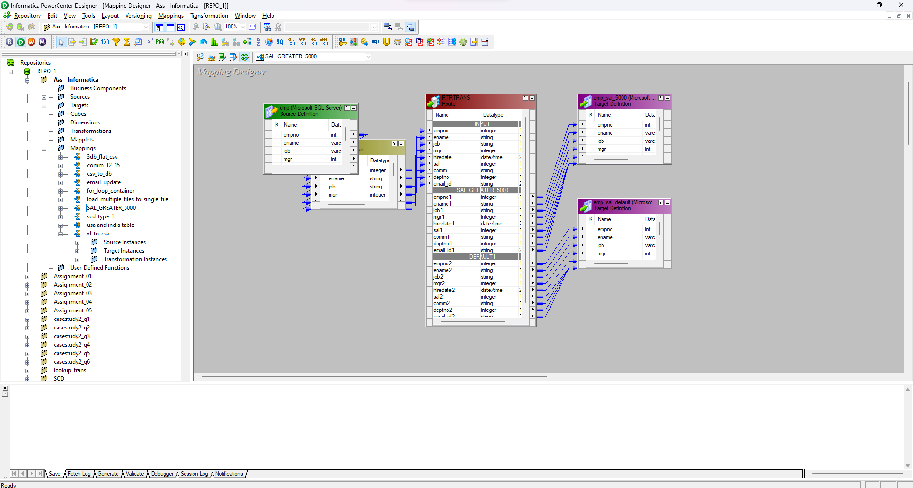

Database:

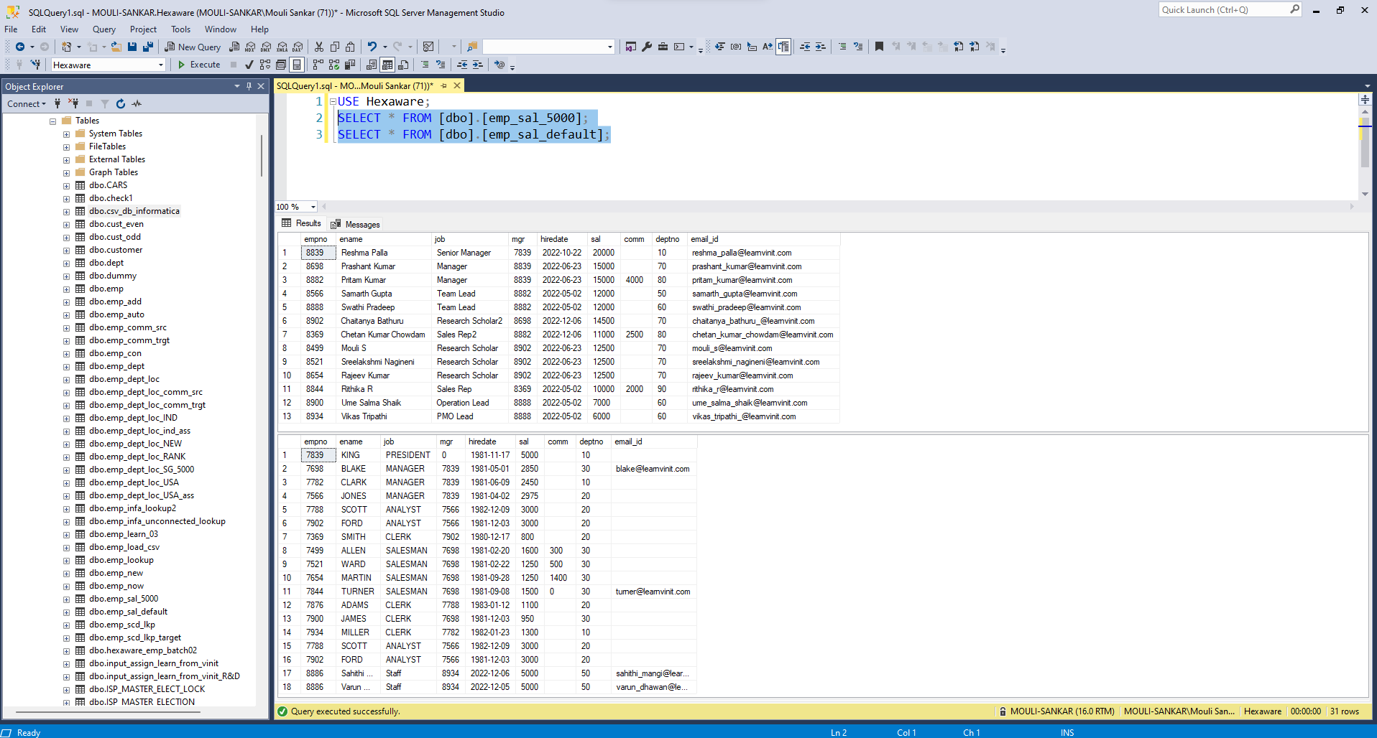

5. Running in loop

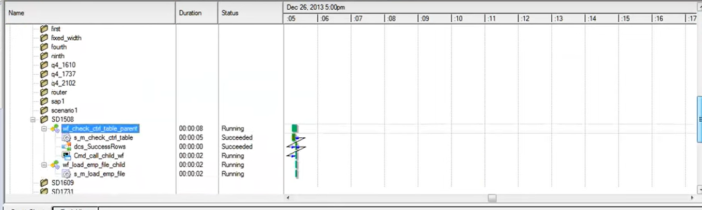

2.2 Questions Set - 02

1. Design job to read 3 tables from SQL Server (Emp, Dept, Loc) and load into flat file.

Mappings:

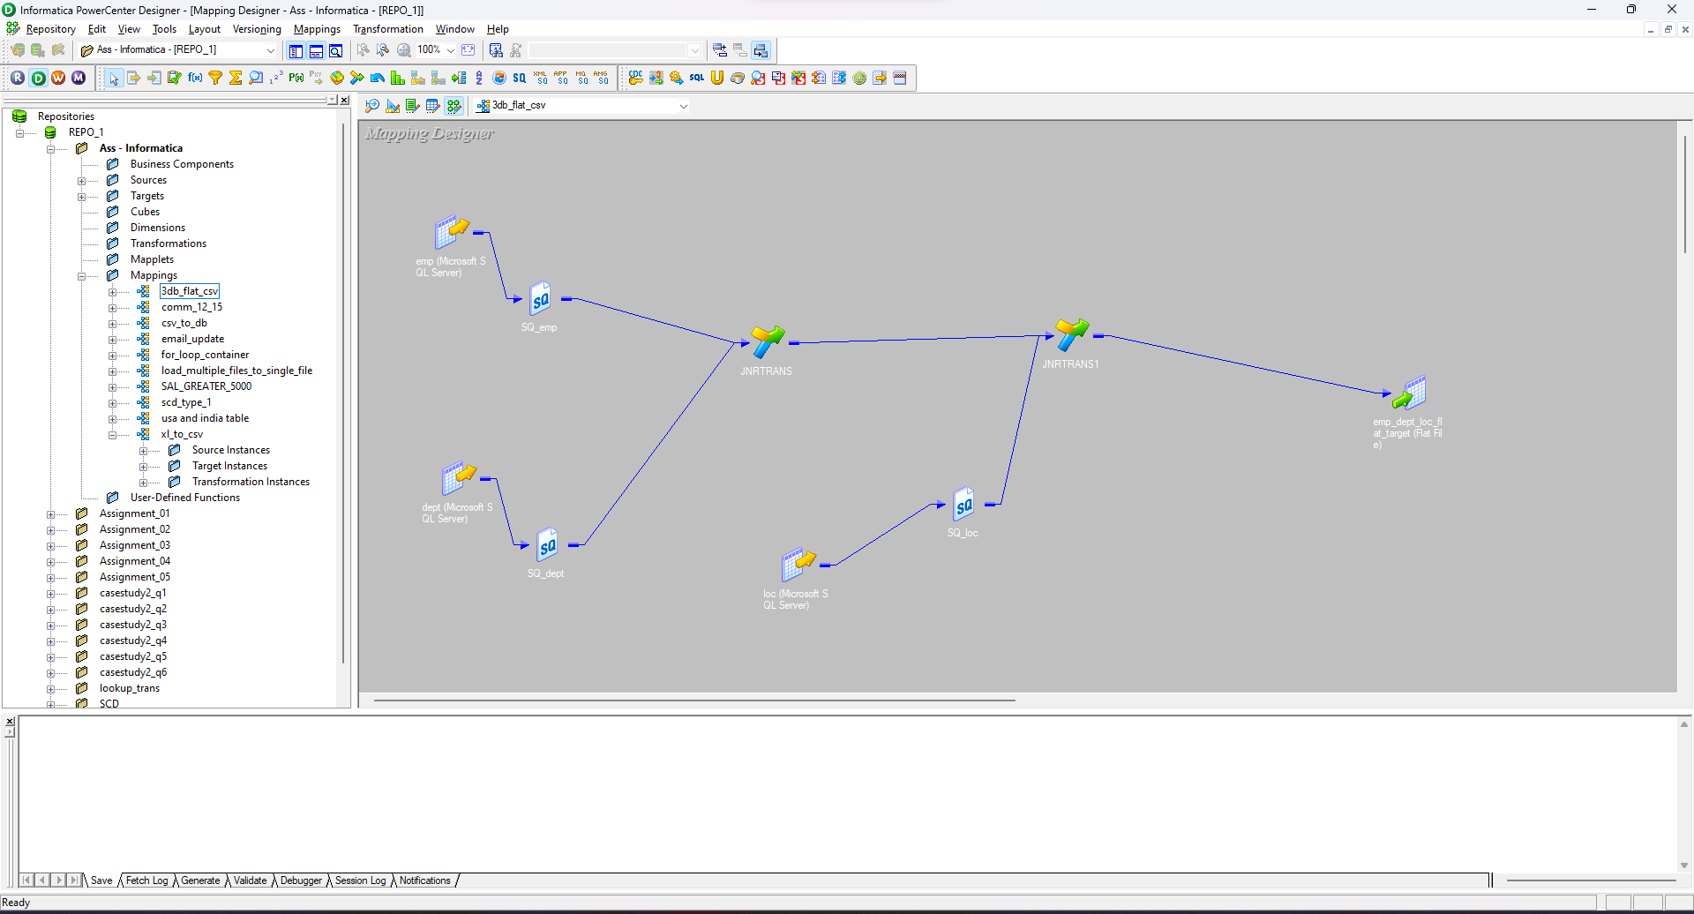

Source

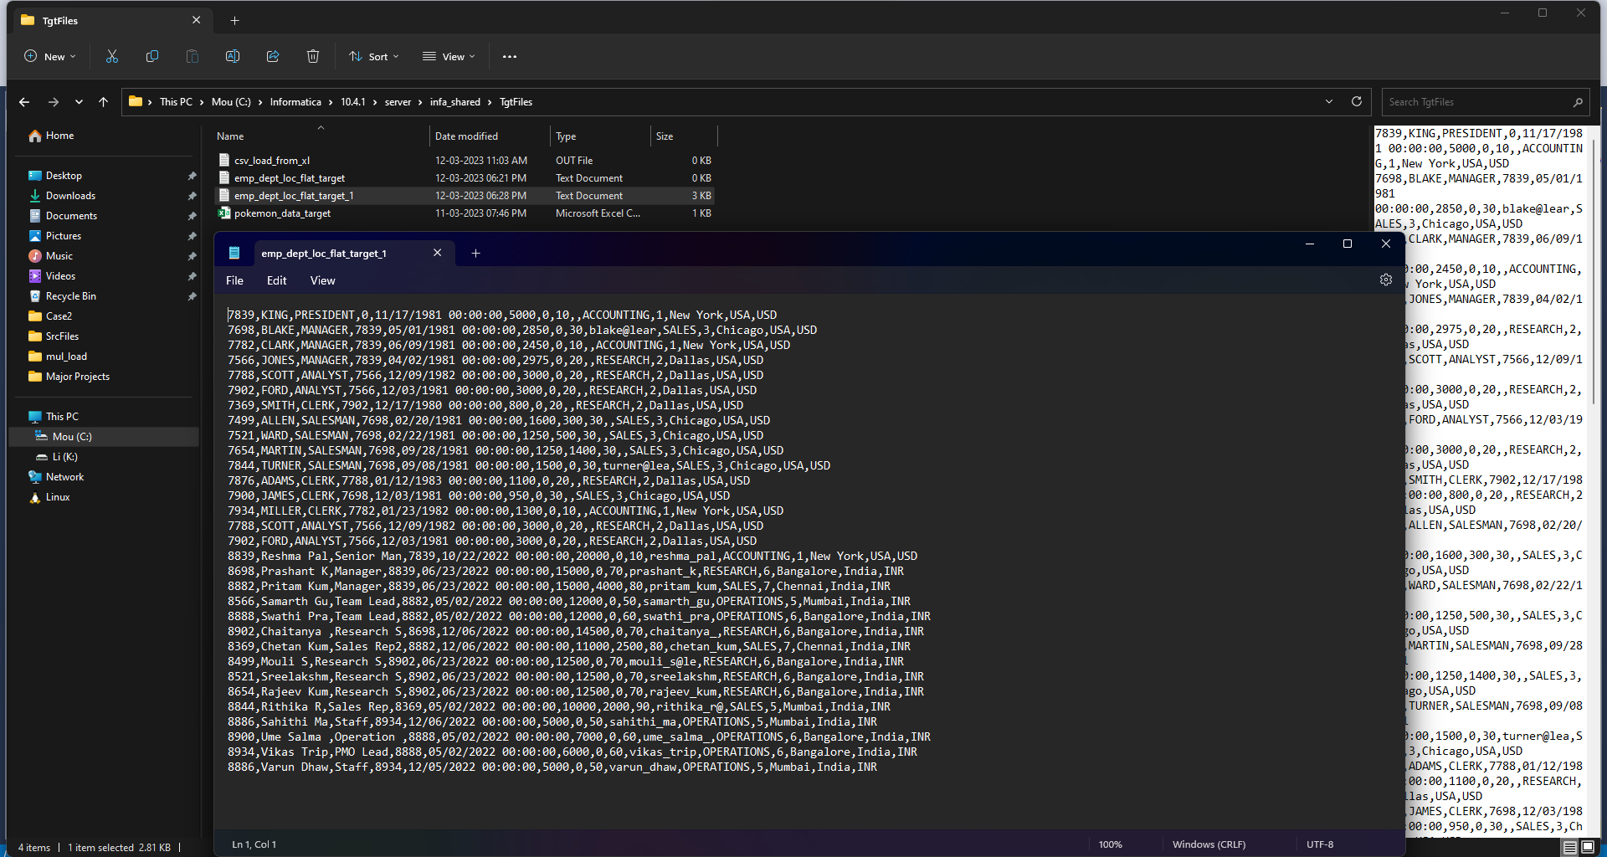

1. Use router transform split data for India and US using source table as Emp, Dept, Loc into 2 target tables.

Mappings:

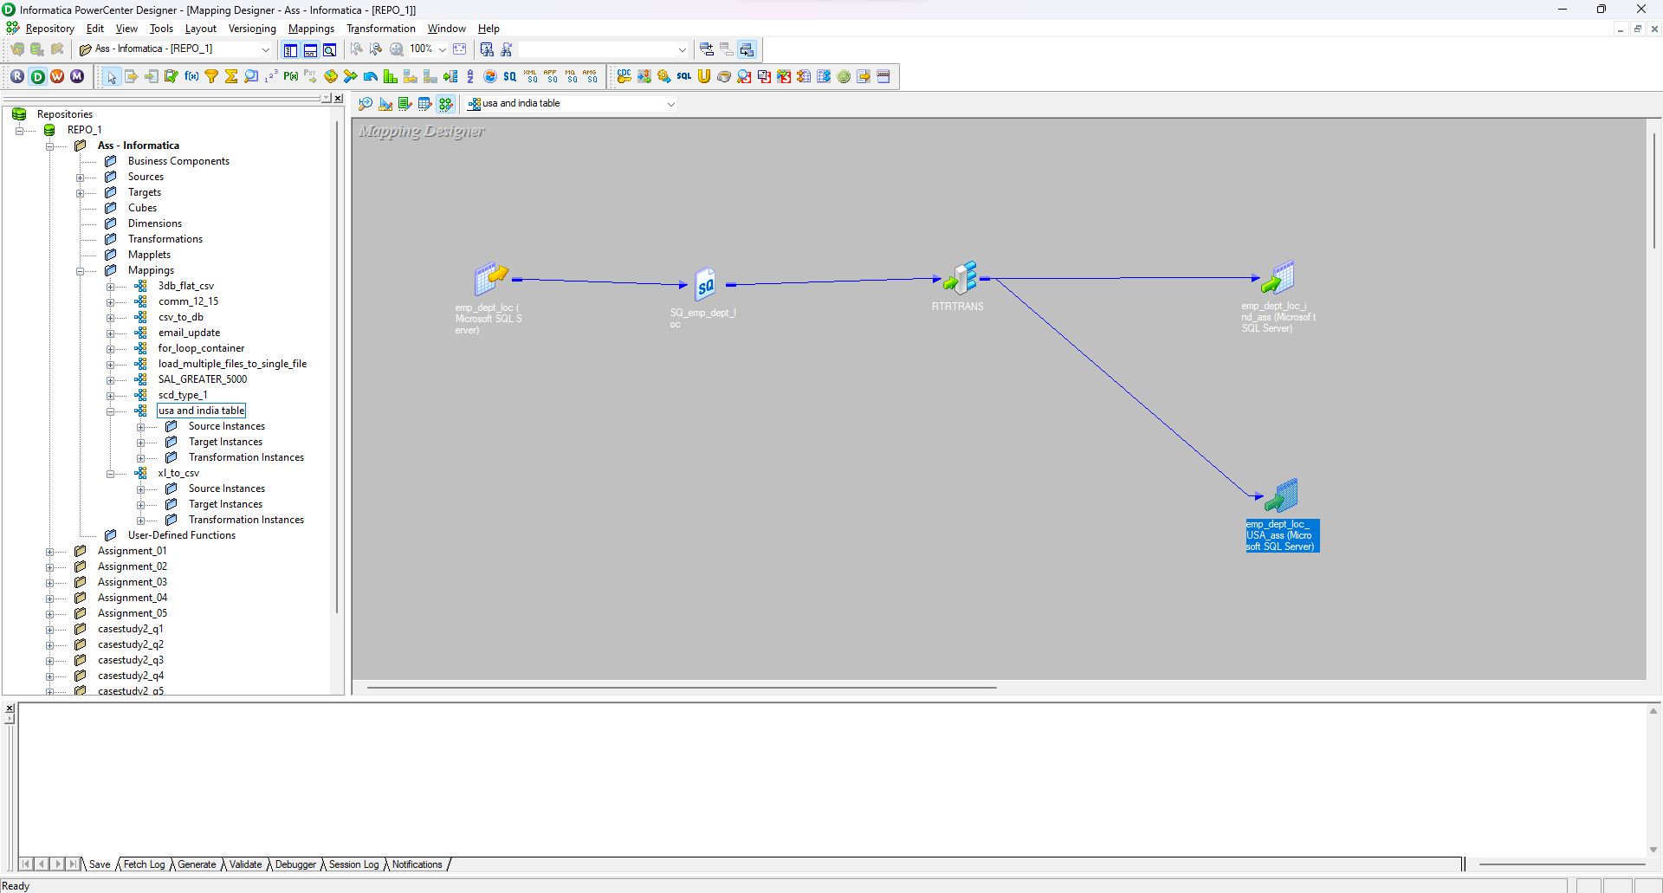

Database:

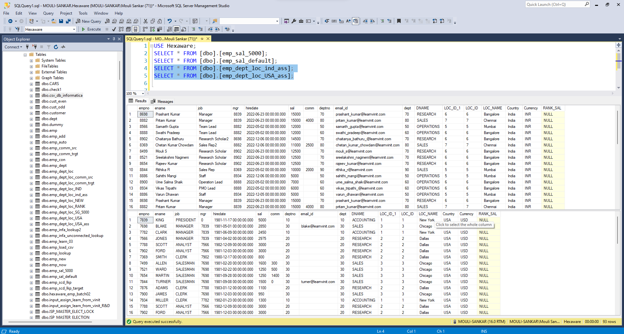

1. Design job to read recursive multiple files from source and load into target table.

Mappings:

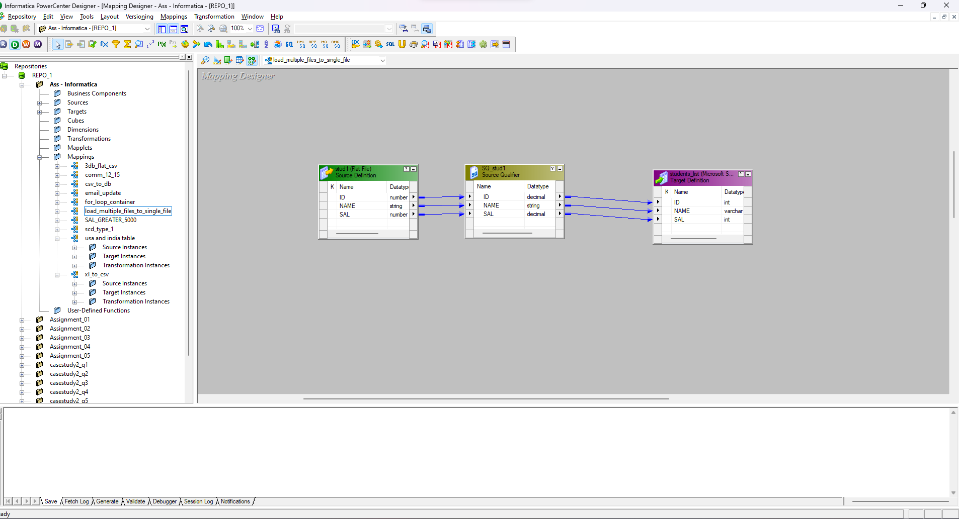

Files:

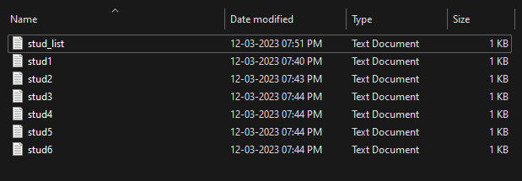

Database:

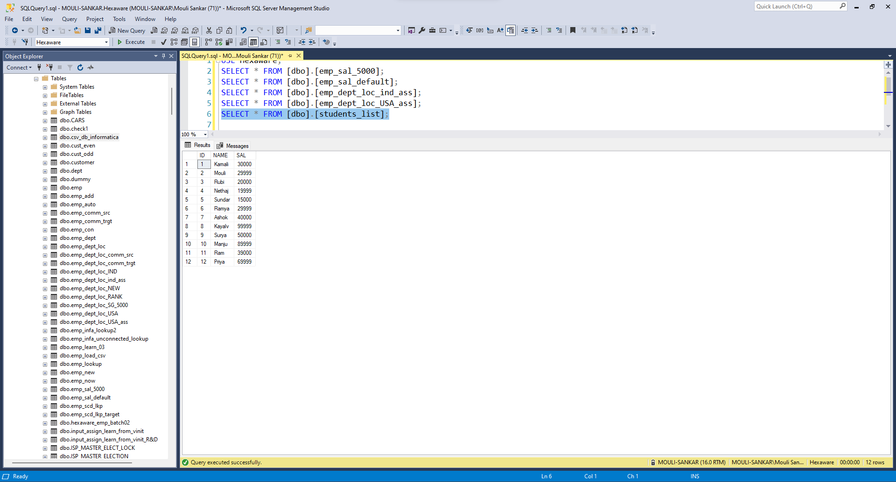

2.3 Questions Set - 03

1. Create Job to load data into target & truncate target table before load.

Workflow:

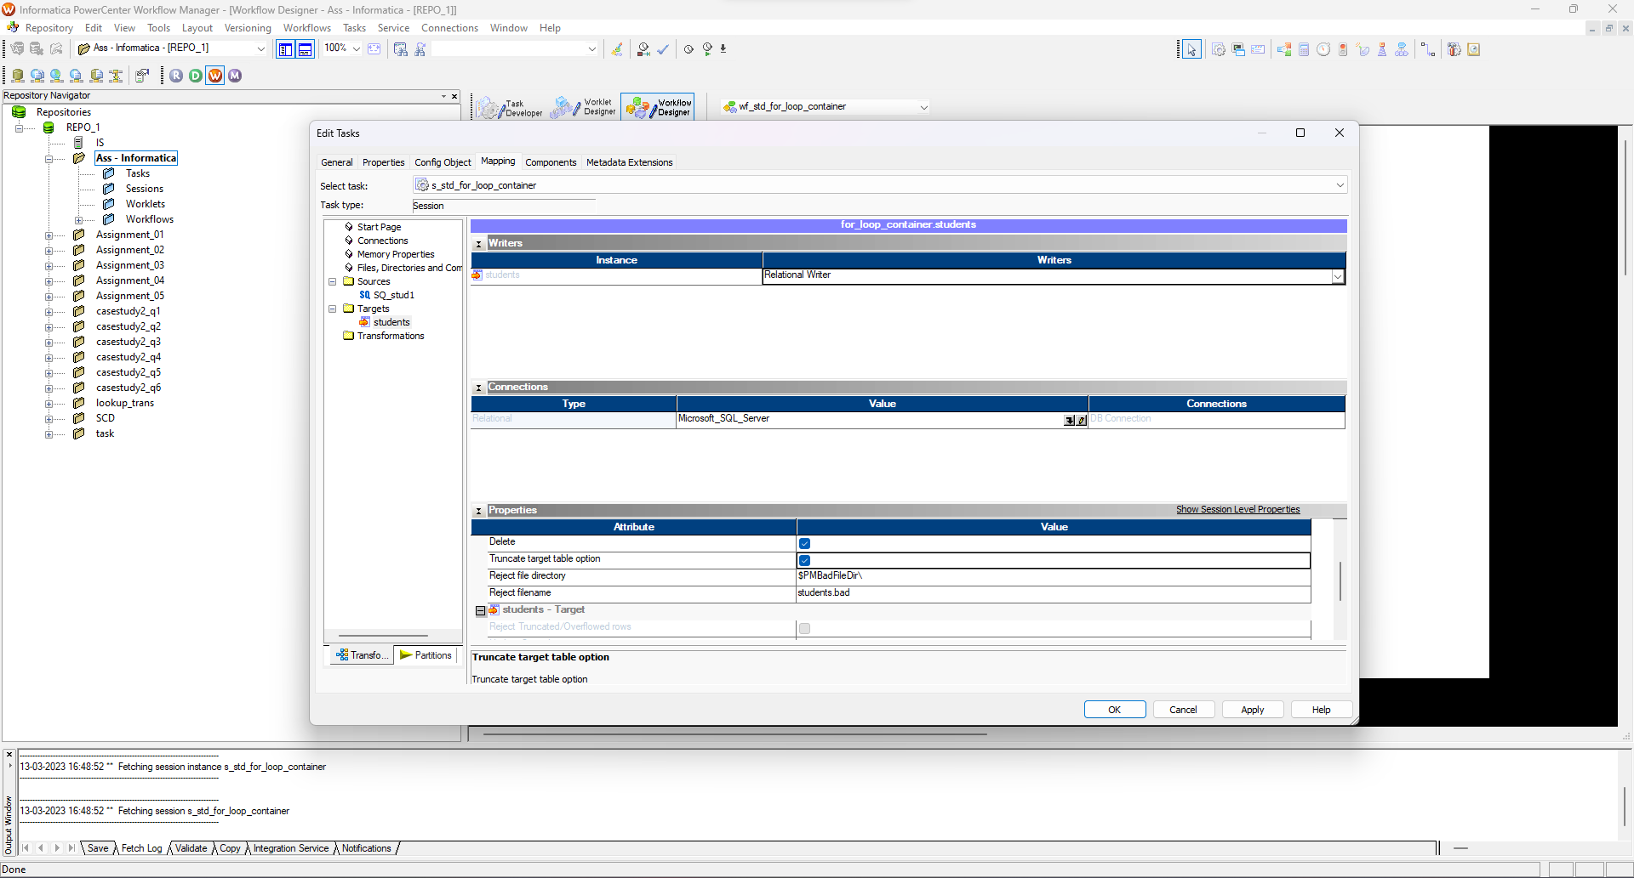

1. Create Job to compute dynamic commission with following condition: a. Country=’US’
   1. Salary less than or equal to 3000 commission is 20%
   2. Else commission is 15%
2. Country=’India’
   1. Salary less than or equal to 3000 commission is 12%
   2. Else commission is 8%

Mappings:

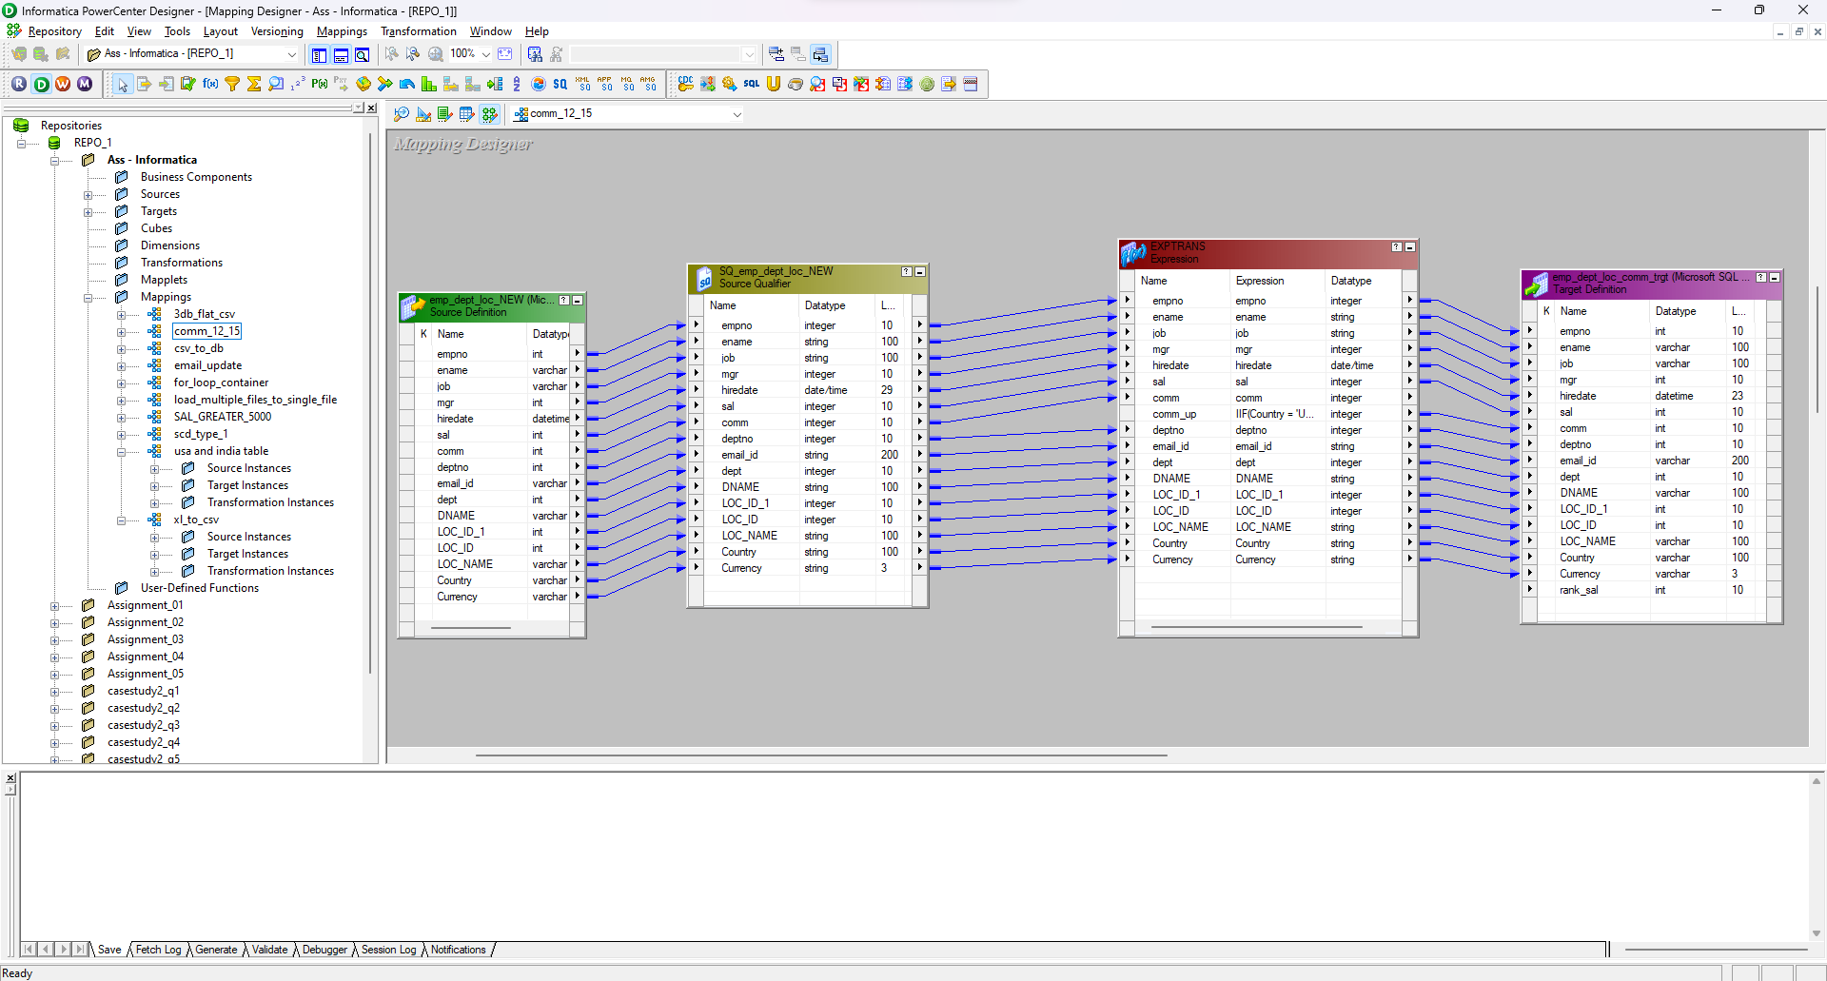

Database:

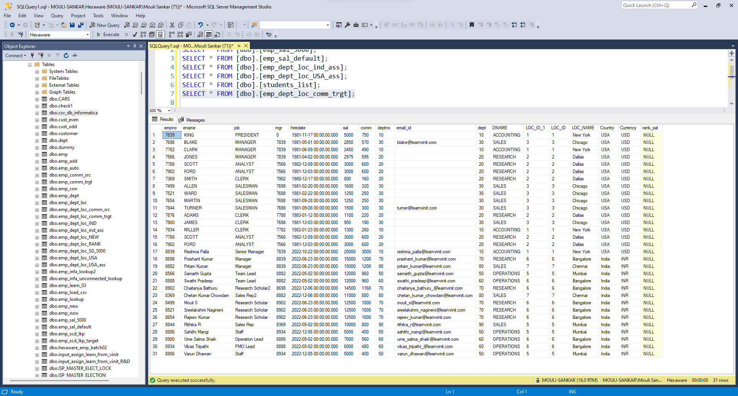

1. Create Job to load data into target using SCD-01 technique.

Mappings:

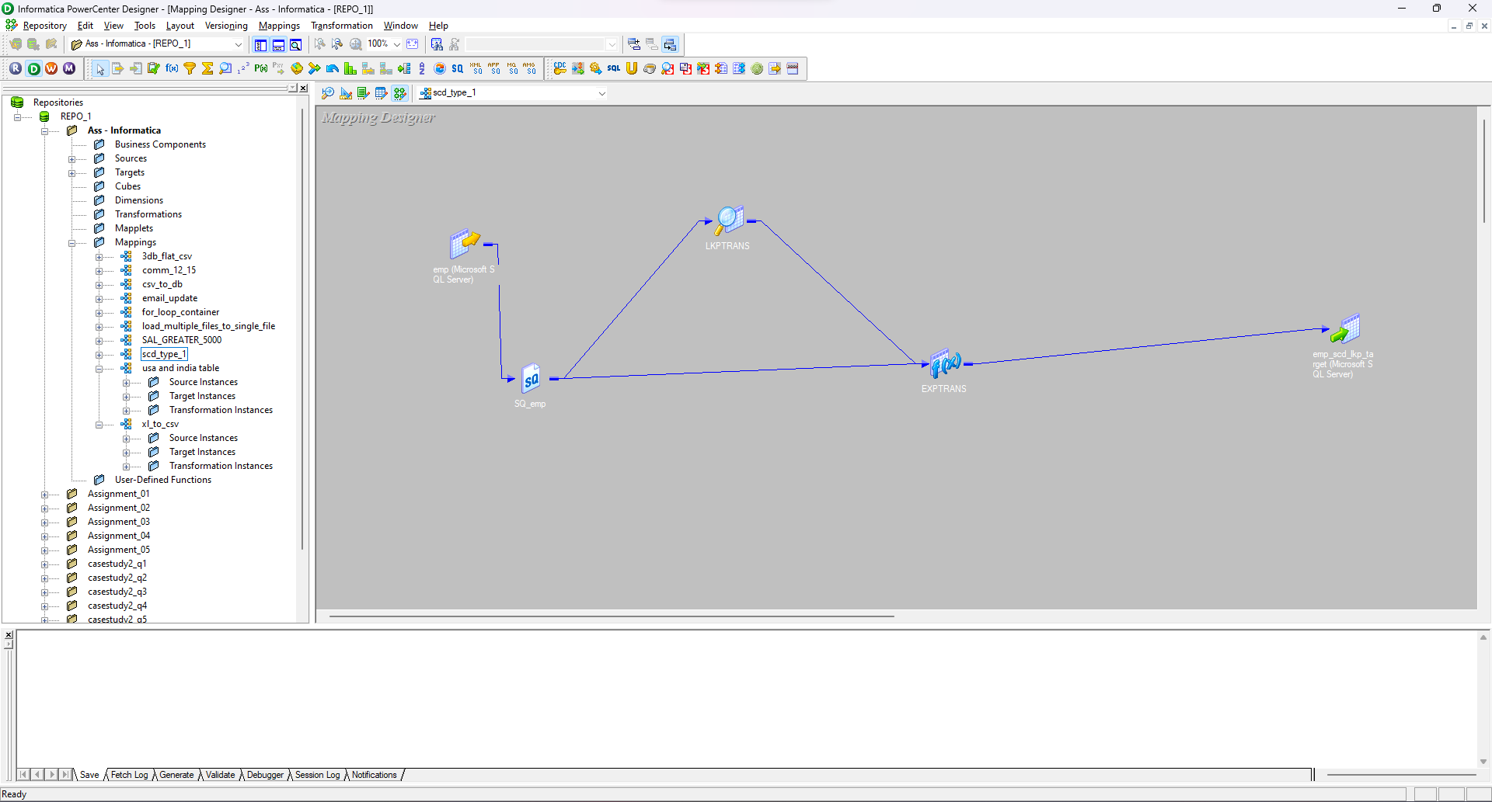

Database:

